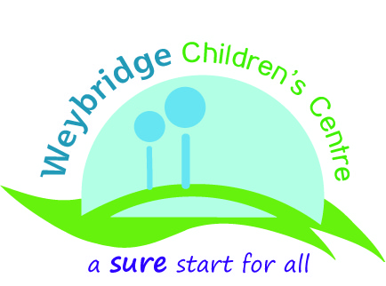

Update from the Weybridge Sure Start Children’s Centre
The Weybridge Sure Start Children’s Centre has moved into the premises! Our website is live on ‘www.weybridgecc.org’!
I am delighted to let you know that we now are based at the Pavilion, Churchfield Road, Weybridge KT13 8DB.
The setting is fabulous and we are working as fast as we can to be up and running. You are welcome to pop in to the centre to come and have a look. Our opening hours will be 9-12 Monday-Saturday from mid June, fingers crossed all will be ready by then.
The centre has many great features; a large main room for social groups, a sensory room for much needed relaxation time and a beautiful, secluded garden.
On Sunday the 20th of June the Weybridge Churches Together ‘Party in the Park’ is taking place from 12.30-3.30pm at the Churchfields Park. The Children’s Centre is supporting this event with activities for the younger members of the families. There will be music, games, bands, face painting, a nursery rhyme challenge and many more things to enjoy. Just bring your picnic and blanket for an afternoon of entertainment and fun.
All families with children aged 0-5 are welcome to join us for the opening celebration of the Weybridge Sure Start Children’s Centre from 11am-1pm on the 10th of July. We are in the throes of organizing this and will keep the surprises under wraps, but please mark the date in your diaries.
Meanwhile we continue our usual programme of activities, with new bookings for the September start of the ‘Parenting Puzzle’ programme (a 10 week course to enjoy family life more) now being taken.
Please contact us with any feedback, for more information or to book on a course. We look forward to hearing from you.
Yvette Stephens and Helena Wright Children’s Centre Advisers 01932 300106
Daphne Sohl Children’s Centre Coordinator 0782 4995202
Sarah Kroner Children’s Centre Outreach Worker 0782 4995250



